Project Based  Learning  - Critical Thinking  - Collaboration  - Communication  - Creativity  Students will participate in in-class activities, research, project products, and an end of project presentations that are in compliance with the Texas State Plan for the Education of Gifted/Talented Students. |  | Communication  - CISD GT website http://www.cisd.org/Domain/162  - GT report cards  - Email ksimmington@cisd.org  - Phone number 903-874-1011  Navarro Elementary School  Schedule  Monday – Carroll  Tuesday – Fannin  Wednesday – Navarro  Thursday – Bowie  Friday – Sam Houston  (GT students will receive services during their Tiger Time.)  Contact Information  Kayla Simmington  903-874-1011  ksimmington@cisd.org |  |  | Corsicana Elementary Schools  - Parent Information  - 2020-2021
1st Grade Projects / Presentations  Fall 2020  The 7 Elements of Art  Students will:  Research several artists from the past and gain a deeper understanding of the expression of art. They will examine how the artist created their masterpiece and develop their own styles.  Spring 2021  Plan a Camping Trip  Students will:  Learn to use a budget to purchases camping materials, measure equipment to design a camp layout, discuss needs and wants, write campfire stories, and plan other exciting camp activities.  Students will:  Learn to budget their money to purchase camping equipment, measure their equipment to design a camp layout, discuss needs and wants, write campfire stories, and other exciting camping activities.  Students will:  Learn to budget their money to purchase camping equipment, measure their equipment to design a camp layout, discuss needs and wants, write campfire stories, and other exciting camping activities.  2nd Grade Projects/Presentations  Fall 2020  Extreme Weather & Natural Disasters  Students will:  Research different types of extreme weather and natural disasters. Their learning will culminate in a “weather / natural disaster report’ reporting a simulated emergency event.  Spring 2021  Mad Scientist  Students will:  Learn how to stay safe in a science lab while exploring the scientific process through experiments. |  | 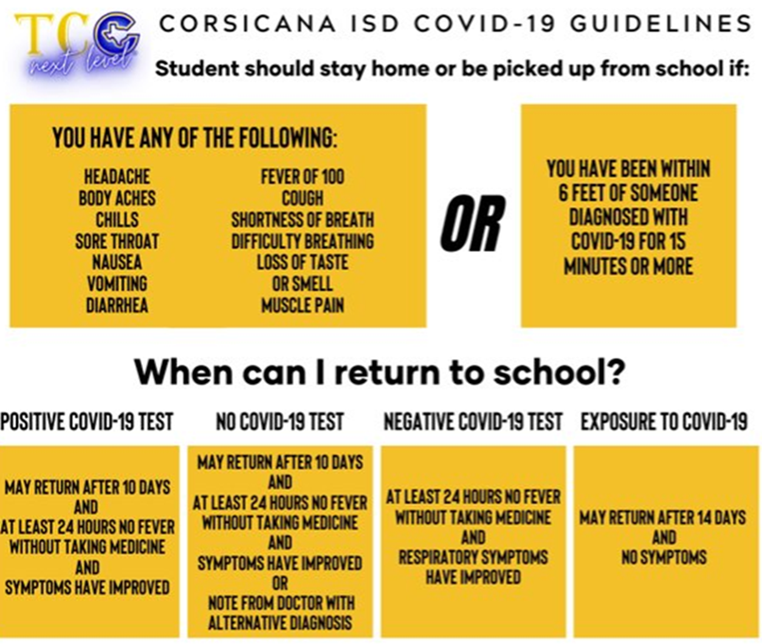  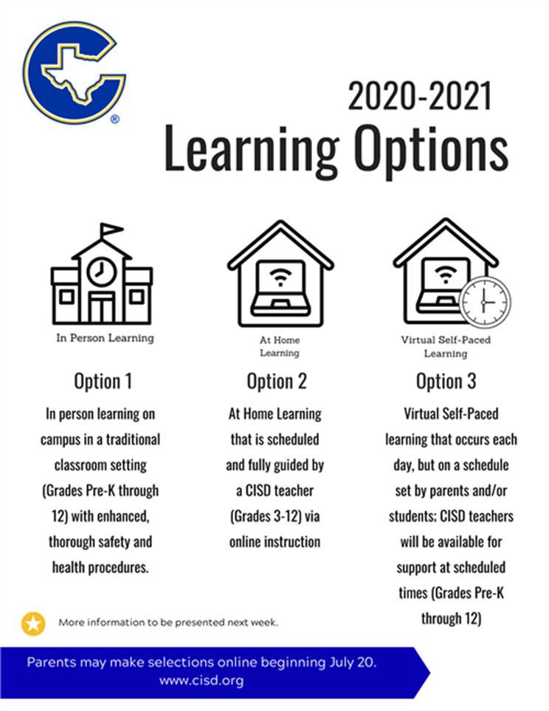 |  |  | 3rd Grade Projects/Presentations  Fall 2020  Treehouse Construction  Students will:  Focus on designing elements, budgeting money for supplies and equipment, find the area and perimeter of the furniture in the treehouse, and create a brochure to advertise their treehouse.  Spring 2021  Lunar Mission  Students will:  Learn the engineering and design process while studying the moon, humans, and their roles in the Solar System.  Your text here  Your text here  4th Grade Projects/Presentations  Fall 2020  Produce a TV Show  Students will:  Write a script for their own TV sitcom, while applying academic and problem-solving skills that filter into real world situations.  Spring 2021  Design and Code a Video Game  Students will:  Examine how the use of design elements effects the quality and success of a video game. They will move from the early developments of taking an idea and turning it into a video game using coding and creative thinking skills.

